**“A Huge Microworld” (English, grades 10-11)**

**Student’s Worksheet**

**Episode 1. The Start of the Exhibition**

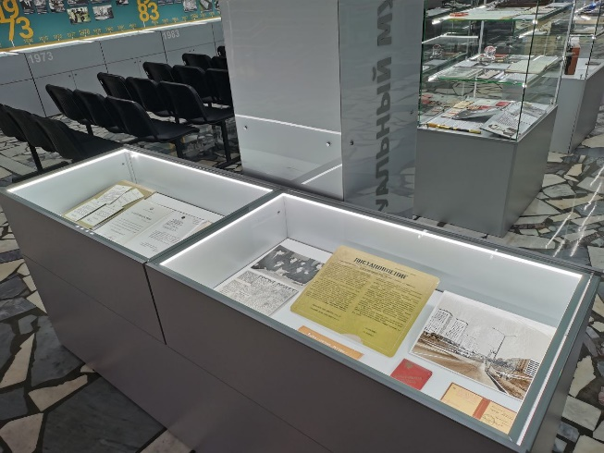

***Task 1A.*** *We are now at the start of the exhibition. It opens with a display case containing historic documents connected with Zelenograd and the museum.*

*Study Decree 248, March, 3, 1958 and say if the information below is true, false or not stated in it.*

1. The new city was to decrease the density (=плотность) of population in Moscow. ___
2. The construction of the city was to start in 1958. ___
3. The first buildings in Zelenograd were to be up to ten storeys high. ___
4. The flats were to be communal and become homes for several families. ___
5. Zelenograd was to have the necessary cultural, social and industrial infrastructure. ___
6. The city was to be connected with Moscow by several bus routes. ___
7. Zelenograd was to become part of Moscow from the start. ___

***Task 1B.*** *All the sentences in Task 1A contain one and the same grammar structure. Can you see it?* ________________________________________________________

*What do we call the verbs that go before other verbs and describe our abilities, duties and wishes?* – _________________________________________________________

*Which ones do you know?* – ______________________________________________

*What do you think the verb “to be” as a modal one means? –* ____________________________________________________________________

*Make three more sentences about Zelenograd using the materials of the display case and the modal verb “to be”.*

____________________________________________________________________________________________________________________________________________________________________________________________________________

***Task 1C.*** *Return to Task 1A and find the English for «плотность». Many words that describe geometrical and physical values (=геометрические и физические величины) came into English from Latin. That is why the Latin letter that stands for the value is also the first letter of the English term (=термин).*

*Use the letters and words from the box below to complete the table.*

t L P r V f m P a

mass surface area energy temperature velocity pressure length diameter time acceleration volume power

диаметр площадь температура энергия скорость сила давление периметр радиус

|  |  |  |
| --- | --- | --- |
| **Latin letter** | **English term** | **Russian term** |
| d | density | плотность |
|  |  | длина |
| S |  |  |
|  | perimeter |  |
|  |  | объем |
|  | radius |  |
| D |  |  |
|  |  | масса |
|  |  | время |
| v |  |  |
|  |  | ускорение |
|  | force |  |
| E |  |  |
|  |  | мощность |
| p |  |  |
| T |  |  |

**Episode 2. The Timeline**

***Task 2.*** *The Russian microelectronics industry has a rich history. Study the timeline along one of the walls and fill in the gaps in the text with dates.*

1. Anders Jonas Ångström [ˈæŋstrəm] (1814-1874) was a prominent Swedish physicist known for his studies of astrophysics, magnetism, thermal engineering and the aurora borealis (=северное сияние). Ångström founded the science of spectroscopy – a science that studies electromagnetic spectra and measures the wavelengths of light. The angstrom is a unit of length equal to 10−10 m. Thus, the name perfectly suits a plant that makes microscopic equipment. The experimental plant *Angstrom* appeared in _____.
2. Among the plant’s first products were *Micro*, the smallest radio receiver in the world created in _____ and popular in the USA, Great Britain and France, and *Electronika 001*, a portable cardiographer designed in _____ and used in a transatlantic expedition.
3. The first Soviet spaceship board computer *Argon 11C* was developed in _____. Under its command for the first time in history a Soviet spaceship made a flight round the Moon and safely returned to the Earth.
4. A calculator is one of the most basic tools we use. The first microcalculator in our country, *Electronika BZ-04*, was designed in _____ and followed shortly by the first Soviet microprocessor in _____.
5. The 80s made an impact on the daily life technology and entertainment industry. In _____ the first Soviet PC, *Electronika BK-0010*, was created. The era of private use began.We remember the year _____ for the legendary *Nu, pogodi!* videogame. It had several spinoffs and developed the player’s planning skills as well as reaction.
6. The 90s began with advances in medical technology. In _____ *Angstrom* launched the production of implantable cardiostimulants of various complexities. By _____ the general production of microelectronic elements for watches, games and other devices in certain market areas had reached 90 % of the global market.
7. Plastic cards and door phones were revolutionary in the 2000s and 2010s. In _____ the plant started making microelectronic units for plastic cards still used today. Home security became tighter in _____ when contact door phone control keys appeared. And the prospects seem more and more intriguing.

**Episode 3. Input Devices**

***Task 3A.*** *Pay attention to the keyboards you see in the museum. What layouts (=раскладки) have you noticed? Why are they different? Read the passage below and put the words in brackets into the necessary form.*

The Epic Evolution of Keyboards: From QWERTY to JCU and Beyond

Keyboards are everywhere – on your laptop, phone, even your smart fridge. But have you ever wondered why the letters 1. (arrange) __________ the way they are? The truth is 2. (exciting) __________ than you think – it’s a story of typewriter wars, language battles, and even Soviet computing history!

The Birth of QWERTY: A Typewriter Accident?

In the 1860s, the American inventor Christopher Sholes 3. (work) __________ on the first practical typewriter. Early prototypes had keys arranged alphabetically, but there was a big problem: if people typed too fast, the metal arms 4. (hold) __________ the letters would crash into each other and jam.

The solution? QWERTY – a layout 5. (design) __________ to slow typists down by placing common letters (like “E” and “R”) farther apart. By the 1870s, Remington, a gun manufacturer (!), mass-produced 6. (typewriter) __________ with this layout. Even though modern keyboards don’t jam, QWERTY stuck around – just like the “save” icon still being a floppy disk!

Fun fact: some claim QWERTY helped salespeople type the word “TYPEWRITER” quickly 7. (use) __________ just the top row. Coincidence? Maybe not!

***Task 3B.*** *Continue reading. Make the necessary words using the ones in brackets. Make all the necessary grammar changes.*

JCU Layouts: Europe’s Keyboard Rebellion

Not everyone uses QWERTY. In Germany, keyboards start with QWERTZ (swapping Y and Z because “Z” is used more, like in “zwei” for “two”). In France, it’s AZERTY – moving letters to fit accents (é, è, ç).

But the weirdest one? The UK keyboard has a tiny “Enter” key and a giant left “Shift” – blame the early British typewriters!

The Russian ЙЦУКЕН: A Soviet Computing Know-how

This layout wasn’t random – it was 1. (care) __________ designed in the Soviet era for typewriters.

Early Russian typewriters experimented with Latin letters before switching to Cyrillic. The ЙЦУКЕН layout placed the most-used Russian letters (like “О”, “А”, “И”) under the strongest fingers. 2. (Punctuate) __________ marks were moved to fit Russian grammar better.

Today, Russian 3. (game) __________ and 4. (code) __________ sometimes switch to “phonetic” layouts, where Cyrillic letters match QWERTY sounds (А = A, Б = B). But ЙЦУКЕН is still king.

**Episode 4. Sterile Chamber**

***Task 4.*** *You have a checklist for a new employee working in a sterile [ˈsteraɪl] chamber for testing modern microchips. However, something has gone wrong and the checklist contains mistakes. Pair up with someone who has a different variant. Instruct each other, find and correct the mistakes. Check if you have corrected all the mistakes with the group and the teacher.*

**Variant 1**

**1. Microchip Quality Control**

* Ensure the microchip is free from defects. ______________________________
* Check for any visible damage. _______________________________________
* Follow the testing protocol precisely. _________________________________
* Record all data accurately in the logbook. ______________________________

**2. Safety Rules**

* Wear protective gear if you wish. _____________________________________
* Avoid sudden movements inside the chamber. __________________________
* Some surfaces must be touched without gloves. __________________________
* Report any safety concerns immediately. _______________________________

**3. Essential Tools**

* Use the microscope for detailed inspection. _____________________________
* Handle the microchip with anti-static tweezers. __________________________
* Keep the water for cleaning ready. ____________________________________
* Dispose of waste in the designated container. ___________________________

**4. Chamber Setup**

* The chamber maintains a sterile, dust-free environment. ___________________
* Air filtration runs periodically. _______________________________________
* Work only under the ultraviolet light when required. ______________________
* Keep the door closed at all times. _____________________________________

**5. Worker’s Attire**

* Wear a full cleanroom suit, gloves, and a face mask. ______________________
* Ensure no skin or hair is exposed. _____________________________________
* Change into sterile shoes before entering. ______________________________
* Keep your jewelry on if it does not interfere with your actions. ______________

***Task 5.*** *Do the Case Task or use its questions for a final discussion.*